**Business Case for Joining ASHB (Association for Smarter Homes & Buildings)**

**Executive Summary**

Joining the Association for Smarter Homes & Buildings (ASHB) offers significant strategic advantages, including access to cutting-edge industry research, advocacy, networking, marketing support, and professional development. With nearly 300 member companies, ASHB provides the resources and connections necessary to stay competitive in the rapidly evolving smart buildings and homes industry. This business case outlines the key benefits and return on investment (ROI) of ASHB membership.

**Sample Members**

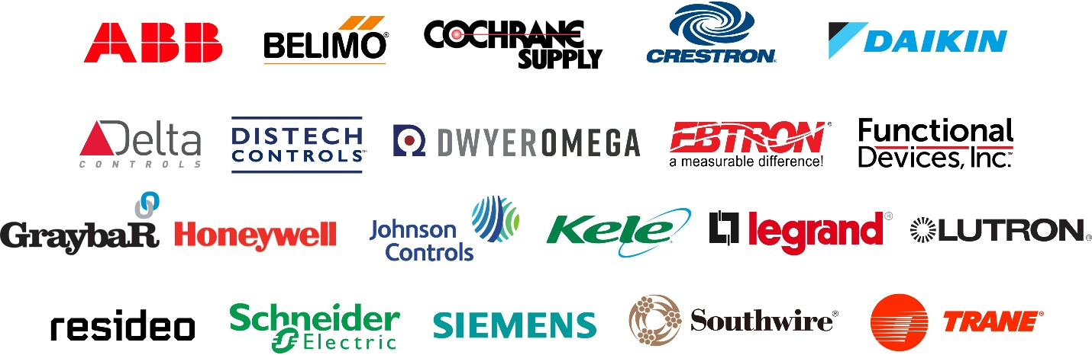

[**CLICK HERE**](https://www.ashb.com/membership/members-directory/) **for the full member directory**

**1. Strategic Benefits of ASHB Membership**

**1.1 Industry Research & Market Intelligence**

**Members Library**: Exclusive access to ASHB’s industry-leading library, with over 1,000 curated reports and white papers, all less than three years old.

**Quarterly Think Tanks**: Informal sessions with industry leaders discussing emerging trends and key research findings.

**Collaborative Research**: Join landmark research projects to gain actionable insights while reducing research costs.

**White Papers & Journal**: Gain critical industry knowledge through ASHB’s white papers and blog, which synthesize key developments in smart building and home technology.

**Discounted Research**: Special discounts on primary research from ASHB-affiliated organizations.

**NewsBrief & Podcast**: Stay informed through ASHB’s weekly industry newsletter and expert-led podcast on smart home and building technologies.

**1.2 Advocacy & Policy Influence**

* Participate in industry-wide efforts to influence policies, regulations, and standards.
* Stay ahead of evolving industry guidelines on cybersecurity, privacy, energy management, and IoT connectivity.
* Ensure your organization’s interests are represented in discussions shaping the future of smart buildings and homes.

**1.3 Networking & Business Development**

* **Councils & Committees**: Engage with ASHB’s **Smaer Home Council (SHC)** and **Smart Building Council (SBC)**, which meet quarterly to discuss sector-specific issues and research priorities.
* **Member Introductions**: Leverage ASHB’s extensive industry network to connect with key players and potential business partners.
* **Review Committees**: Participate in research and white paper review committees to contribute to industry knowledge and best practices.

**1.4 Marketing & Brand Visibility**

* **NewsBrief & Social Media**: Promote your company’s articles, media releases, and announcements to over 12,000 industry subscribers.
* **Advertisements & Email Campaigns**: Target key industry professionals through ASHB’s advertising and email marketing opportunities.
* **Speakers’ Bureau & Event Promotion**: Gain speaking opportunities at ASHB-endorsed events and webinars to showcase thought leadership.
* **Podcast & Editorial Contributions**: Contribute to ASHB’s blog and podcast to increase industry visibility and credibility.

**1.5 Professional Development & Education**

* **Workshops & Webinars**: Access training sessions and expert discussions on industry best practices, regulations, and emerging technologies.
* **Industry Reports & Research**: Stay ahead of key trends, policy updates, and technological advancements through ASHB’s research initiatives.
* **Leadership Opportunities**: Join ASHB committees and councils to play an active role in shaping industry discussions.

**2. Return on Investment (ROI) Analysis**

ASHB membership delivers tangible and intangible benefits, including:

* **Increased Revenue Opportunities**: Access to new business leads, industry referrals, and potential clients through networking and marketing.
* **Cost Savings**: Discounts on research, training, and event participation.
* **Competitive Advantage**: Early access to emerging trends, regulatory insights, and cutting-edge technologies.
* **Stronger Industry Influence**: Active participation in shaping policies and industry standards affecting smart buildings and homes.

**3. Conclusion & Recommendation**

Joining ASHB is a strategic decision that enhances business growth, industry influence, and professional development. By leveraging ASHB’s research, advocacy, networking, marketing, and education opportunities, our organization will gain a competitive edge in the smart buildings and homes sector. It is recommended that we proceed with ASHB membership to maximize these benefits and strengthen our industry presence.