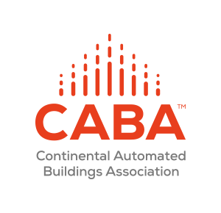
CABA Connected Home Council (CHC) Meeting AGENDA
Wednesday, May 20, 2020, 12 NOON – 1:30 PM (ET)

CABA CHC Chair and Vice-Chairs invite you join and participate in the next CHC Webinar meeting. Everyone is encouraged to participate. For past minutes, list of CHC members, supporting documents and other CHC information, please go to: www.caba.org/chc.

“Evidence-Based Ways To Make Homes Safer and Healthier Post COVID-19”
Special 30 Minutes Presentation
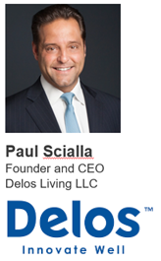

Description: Paul will discuss how to make homes safer and healthier places to live post COVID-19 using evidence based models. Paul will also outline how Delos is using evidence-based health and wellness technologies and solutions in the Vatican’s Orientale residences. “We know that buildings have a profound impact on human health, but the current pandemic has magnified the essential need for evidence-based health interventions in the indoor environment, which are being shared with the Vatican and its global network.” Paul Scialla, Founder and CEO of Delos. Read more.

AGENDA

- Agenda -- Greg Walker (CABA)

- Call to Order, Welcome, Introductions, about the CHC -- Roy Perry (Alarm.com)

- Administrative -- Roy Perry (Alarm.com)
  - Motion to approve past CHC Minutes: www.caba.org/chc
  - Motion to approve Jim Hunter (Delos Living LLC) as a new CHC Vice-Chair

4. “Evidence-Based Ways To Make Homes Safer and Healthier Post COVID-19” (30 min) – Jim Hunter (Delos Living LLC), Paul Scialla (Delos Living LLC)

5. Research Update – Danny Sran (TELUS)
“Privacy and Cybersecurity in the Connected Home” 2020 CHC Landmark Research

6. White Paper Sub-Committee Update -- Ken Wacks (Ken Wacks Associates)
6.1 Recently Complete: “The Evolution of Integrating LiFi Technology into Smart Lighting and Control Systems for the Intelligent Building”
6.2 In Progress:
“Power over Ethernet (PoE) & Digital Electricity (DE) in Commercial and Multiple Dwelling Residential Buildings”
“Human Centric Lighting: Non-Energy Benefits of Lighting and its Smart Controls”
“Connected Home Cybersecurity Regulations”

7. New Business -- Lauren Taylor (Frost & Sullivan), Roy Perry (Alarm.com)
  - Invitation to Growth Opportunity Trends and Diagnostic Session with Frost & Sullivan
  - Other new CHC business?

8. Adjournment -- Roy Perry (Alarm.com)
Next CHC Meeting, Early August, 2020

For additional information, contact CABA at caba@caba.org, 613.686.1814, or www.caba.org.

